**DAILY ONLINE ACTIVITIES SUMMARY**

|  |  |  |  |  |  |  |  |  |
| --- | --- | --- | --- | --- | --- | --- | --- | --- |
| **Date:** | **20/06/2020** | | | | | **Name:** | **NIKHIL KUMAR** | |
| **Sem & Sec** | **4thSEM. & ‘B’ SEC.** | | | | | **USN:** | **4AL19CS400** | |
| **Online Test Summary** | | | | | | | | |
| **Subject 1** | | **DATA COMMUNICATION** | | | | | | |
| **Max. Marks** | | **30** | | **Score** | | | **22** | |
| **Certification Course Summary** | | | | | | | | |
| **Course** | **BitDegree** | | | | | | | |
| **Certificate Provider** | | |  | | **Duration** | | |  |
| **Coding Challenges** | | | | | | | | |
| **Problem Statement1 : Write a java program to count numbers of bits to be flipped to convert A to B.**  **Problem Statement2 : Program to compares counting counting words in files using an ArrayList and a map using java programing.**  **Problem Statement3 : Write a java program to rotate an array by K positions.** | | | | | | | | |
| **Status:executed** | | | | | | | | |
| **Uploaded the report in Github** | | | | | **Yes** | | | |
| **If yes Repository name** | | | | | 1. <https://github.com/Nikhil401/java-coding/blob/master/SimpleWordCounter.java> 2. <https://github.com/Nikhil401/java-coding/blob/master/main.java> 3. <https://github.com/Nikhil401/java-coding/blob/master/Flipped.java> | | | |
| **Uploaded the report in slack** | | | | | **Yes** | | | |

**Online test Summary: subject Data Communication was scheduled from 02:00 to 02:30 pm. There was 30 questions and each contains 1 mark.**

**Snapshot is given below:**

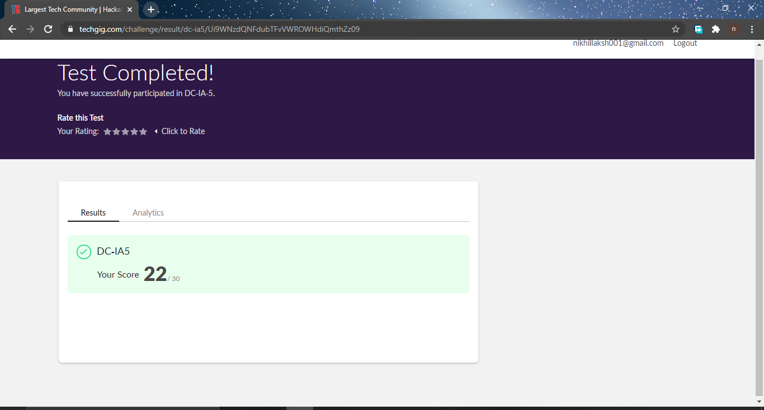

**Certification Course Summary: Today I have done certification course “Introducing code for beginners” and the snapshot of the certificate is given below:**

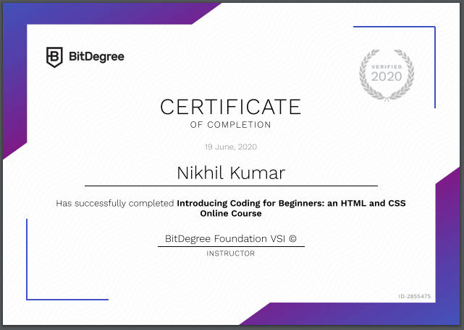

**Online Coding Summary: Today I received programs from prof . venkatesh and prof. shilpa and prof. vasudev CSE Dept. The program is mentioned above(pg.01). to my GitHub repository link and I’ve shared the snapshot below.** 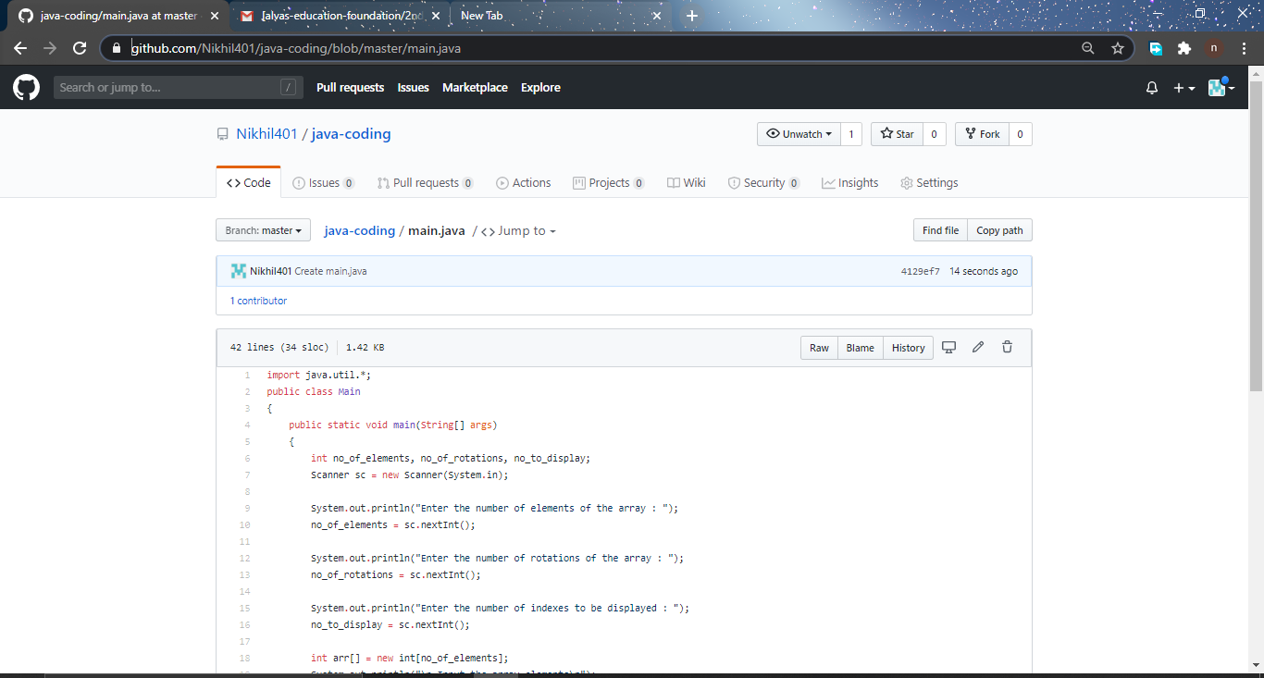

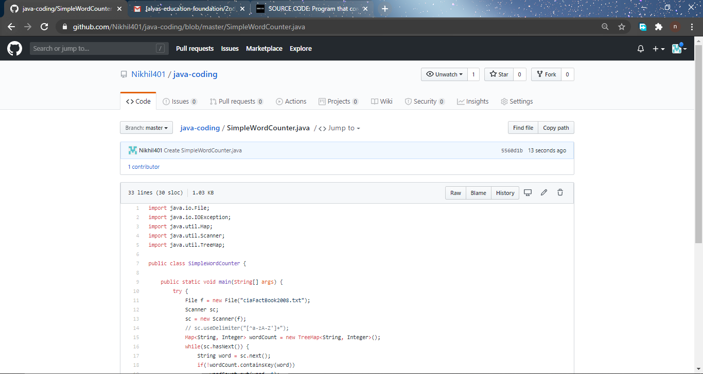

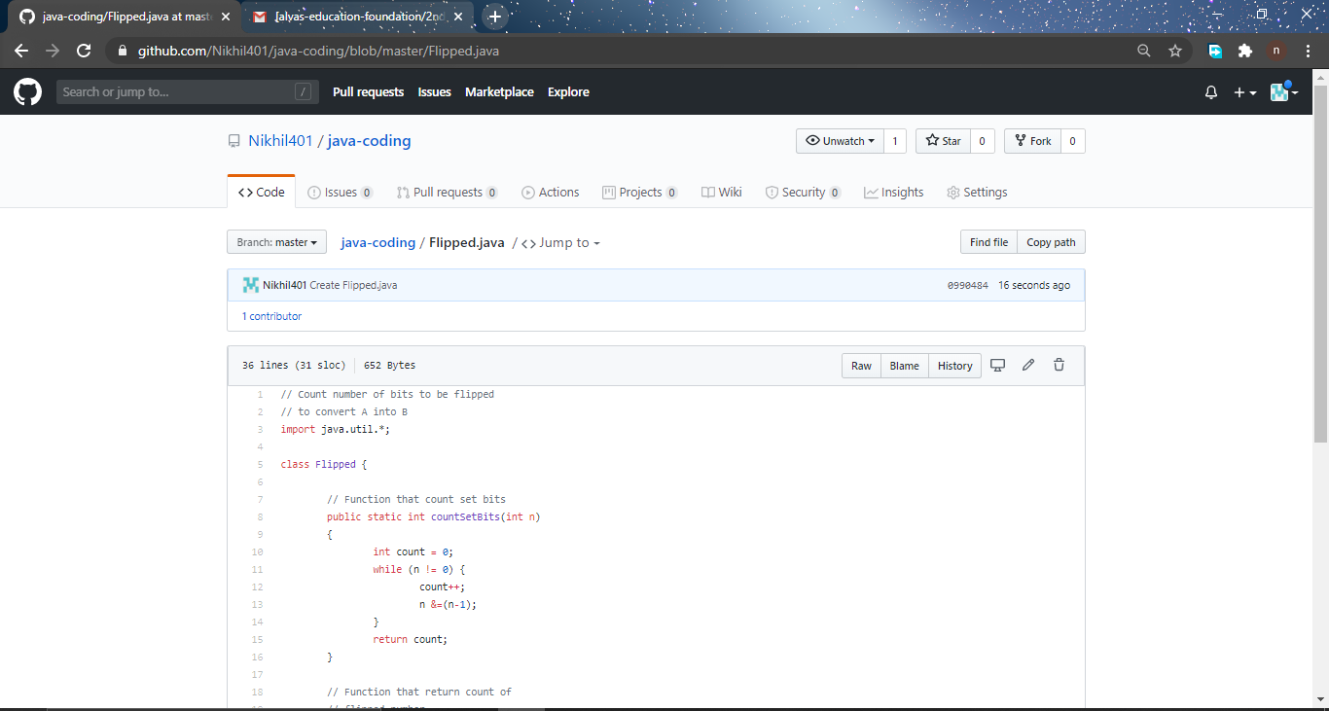 **Thank you.**